



2025

ESTATE PLANNING FORUM



Thursday, May 22, 2025

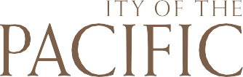

8:00 a.m. - 4:30 p.m.



8:00 – 8:30 Registration and Breakfast

8:30 – 8:45 Opening Remarks: Liza Bunker – President

8:45 – 10:15 Sam Donaldson – “Recent Tax Developments in Estate Planning”

10:15 – 10:25 Break

10:25 – 11:55

Tiffany Teel House - “Gifts of Real Estate Assets”

11:55 – 12:50 Lunch / McGeorge Scholarship Presentation

12:50 – 1:50

Philip J. Hayes – “California Directed Trusts - A Big Step Forward for California Trust Law, But What Happens Now?”

1:50 – 2:00 Break

2:00 – 3:00 Erin Norcia – “Estate Law Updates You Should Know”

3:00 – 3:15 Break

3:15 – 4:15 Emily Koochel – “Using Financial Psychology to Better Connect with Clients”

4:15 – 4:30 Closing Remarks: Liza Bunker – President

4:30 – 5:45 Networking/Mixer/Wine Reception